_{SNEAKER ODOR CONTROL BALLS}
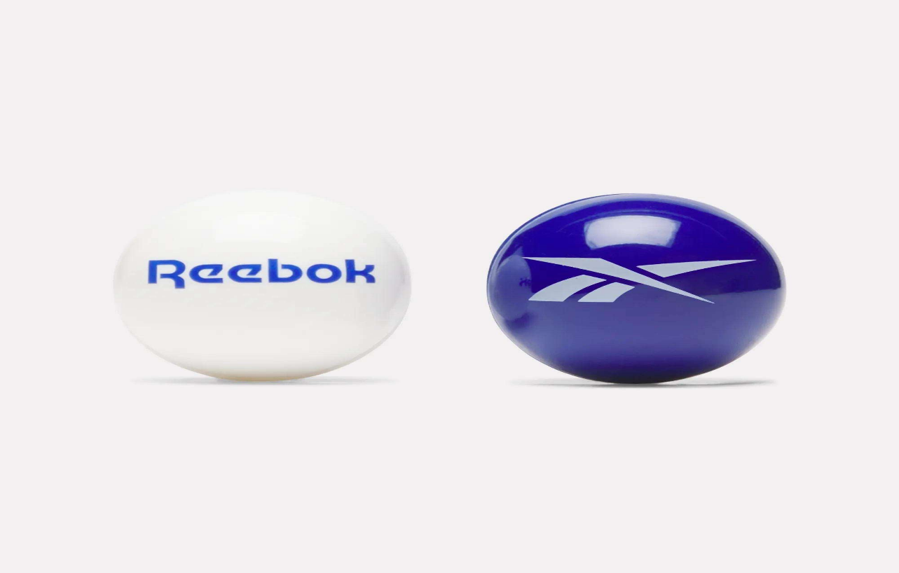
PRICE: Approximately Rs. 1,499

_{Introduction:}
The Reebok Sneaker Odor Control Balls are a simple yet highly effective solution designed to keep your footwear fresh, clean, and odor-free. Whether you wear sneakers daily, hit the gym regularly, or store shoes for long periods, these odor control balls work continuously to neutralize unpleasant smells at the source. Compact in size but powerful in performance, they are easy to use and fit comfortably inside shoes, gym bags, lockers, or drawers. Backed by Reebok’s reputation for quality sports accessories, this product is ideal for anyone who values hygiene, freshness, and long-lasting shoe care.
Product Overview:
These odor control balls release a fresh, clean scent that actively fights odor-causing bacteria. Simply place them inside your shoes after use, and they start working immediately no sprays, no mess, no maintenance.
About the Brand:
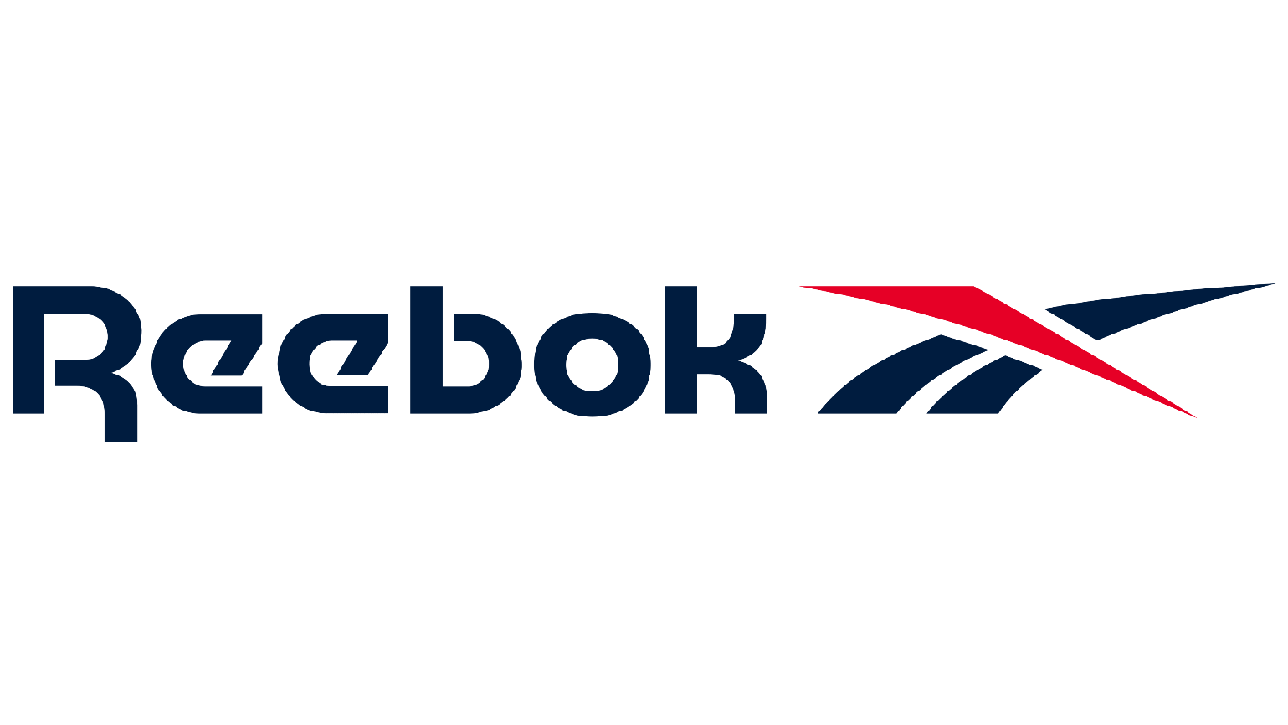
Reebok is a globally recognized sports and fitness brand known for producing reliable, high performance athletic gear and accessories. With decades of experience in sports innovation, Reebok products are trusted by athletes and everyday users alike for quality, durability, and practical design.

Key Features:
- Eliminates odor caused by sweat and bacteria
- Long-lasting fresh fragrance
- Compact and lightweight design
- Easy to use no charging or refills needed
- Suitable for shoes, bags, lockers, and drawers

Design & Build Quality:
The odor control balls feature a durable outer shell with a ventilated design that allows the fragrance to disperse evenly. Their compact spherical shape ensures they fit easily into all types of footwear without damaging the shoe interior. The twist-to-activate mechanism ensures controlled fragrance release while keeping the deodorizing core safely enclosed.
Storage & Capacity:
Designed for individual or pair usage, each ball is small enough to store inside shoes, gym bags, or storage compartments. Ideal for daily use and long-term storage.
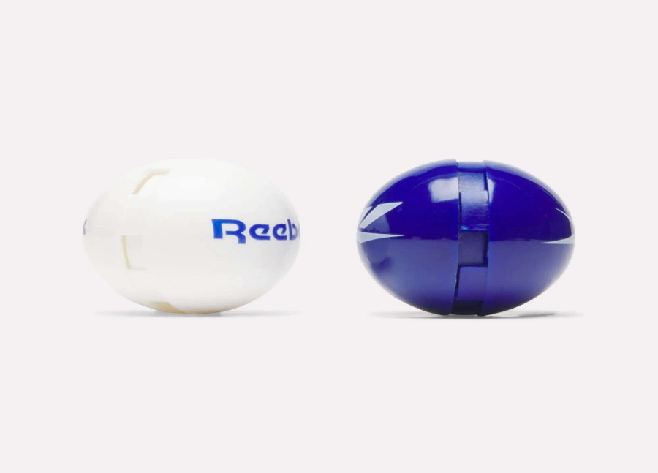

Material & Durability:
Made from high-quality plastic with a solid build, these balls are resistant to cracking and everyday wear. The internal deodorizing material remains effective for an extended period.

Ideal For:
- Eliminates odor caused by sweat and bacteria
- Long-lasting fresh fragrance
- Compact and lightweight design
- Easy to use no charging or refills needed
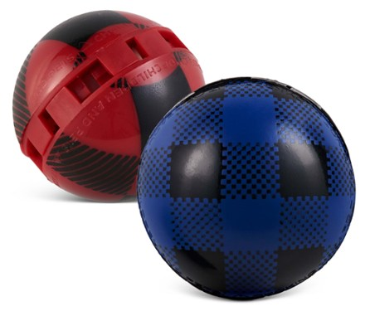
- Suitable for shoes, bags, lockers, and drawers

Care Instructions:
- Keep away from direct heat or sunlight
- Do not wash or submerge in water
- Store in a dry place when not in use
Product Specifications:
- Brand: Reebok
- Product Type: Sneaker Odor Control Balls
- Material: Durable plastic shell
- Fragrance Type: Fresh deodorizing scent
- Usage: Shoes, bags, lockers
- Quantity: Pair (2 balls)
Product Summary:
The Reebok Sneaker Odor Control Balls offer a hassle-free way to maintain shoe freshness and hygiene. Compact, durable, and highly effective, they are a smart addition to your daily footwear care routine perfect for sports enthusiasts and everyday users alike.

